Instructions for Program Directors:

Instructions for obtaining approval for moonlighting opportunities are now also available to your trainees. UCLA Moonlighting Request forms are available on the MedHub home page in the Moonlighting Information folder in Resources/Documents section, as well as on the GME website.
Significantly, while internal moonlighting was not approved before, the GMEC has now agreed that eligible housestaff may participate in internal moonlighting opportunities (paid by UCLA if approved by you as Program Director, and GME). The moonlighting policy describes both types of experiences (internal vs. external); please contact any of the GME Office Staff if this policy is not clear to you.
If trainees in your program engage in moonlighting, either internal or external, you as the Program Director are responsible for the following:
- Approving or rejecting Moonlighting Requests in MedHub. These will appear in your “Urgent Tasks” box with a link to the request. Please open and review the UCLA Moonlighting Request & Approval Form attached to the request by the trainee. Incomplete forms, incorrect forms, or requests that place the trainee in danger of violating ACGME Duty Hour rules should be rejected.
- Monitoring the Resident/Fellow timesheets of those trainees engaged in moonlighting to verify entry of duty hours on the timesheet, and compliance with duty hour rules in light of additional work hours outside of usual residency training.
Your residents/fellows must identify hours as “moonlighting” in MedHub when they are entered on the timesheet and they have been provided instructions for doing so.
Please contact the GME Office Staff with any questions regarding the moonlighting policy or approval process.

Following is a brief outline of the moonlight permission request and approval process:
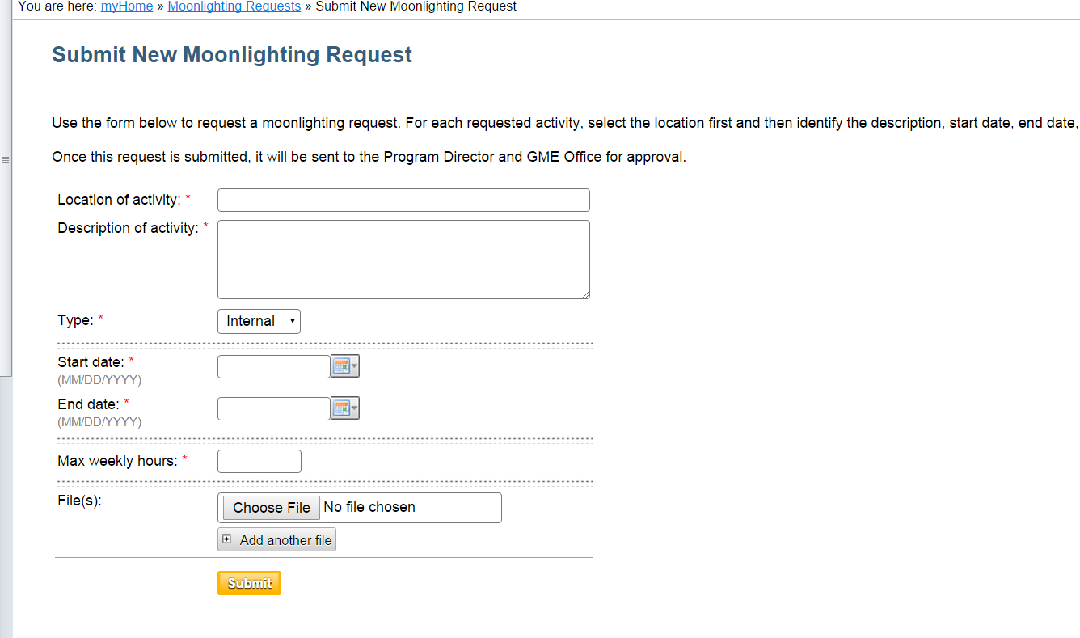
- Resident completes UCLA Moonlighting Request & Approval Document form (open, save as pdf document, complete requested info including “signature acknowledgement”), saves form.
- Resident selects “Moonlighting Requests” and enters the information on MedHub – minimal (location, brief description, inclusive dates and max hours/week they anticipate moonlighting), uploads completed form. NOTE: Requests may only be for dates within the current academic year.
- Request with attachment will then forward to Program Director who will receive a “New Moonlighting Request” link in the URGENT TASKS BOX. Select the link to go to the request – open the form to ensure you are familiar with the request, and that all of the requested information is complete, etc.
- PD approval prompts GME Director to review, then approve or reject. GME checkpoints include verifying eligibility, maximum hours being requested/feasibility of request given demands of training, form completely filled in, etc. GME receives the request once approved by the Program Director.

